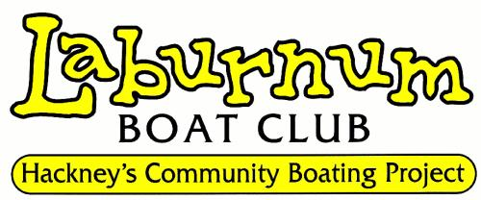
Laburnum Boat Club
Laburnum Street, London. E2 8BH
02077292915
info@laburnumboatclub.com
www.laburnumboatclub.com

Job Application Form

Post applied for:
Assistant Youth Worker (Intern)

Applicant name: Date of Birth:

Address:

Tel: email:

Current Employment:

From: | Position held: | Employer’s name & Address: |  | Responsibilities/Duties:
Employment History: (inc. Voluntary Work
From: To: | Position held: | Employer’s name & Address: |  | Responsibilities/Duties:
Employment History: continued
From: To: | Position held: |  | Employer’s name & Address: | Responsibilities/Duties:
Education History:
From: To: | College/School or Venue: | Courses/Training attended: |  |  | Grades

Other Relevant Qualifications: (such as: Youth Work, Safeguarding, First Aid etc)

Do you hold a current Enhanced DBS check? YES / NO *delete as applicable

Supporting Statement (please refer to person specifications):
Continue on a separate sheet if necessary.

Please give the names and addresses of two people who are willing to act as referees.

If you are currently employed one must be your present employer or latest education establishment (no friends or family please).

Reference 1. | Reference 2.
Name:  Position:  Address:  Email:  Tel: | Name:  Position:  Address:  Email:  Tel:

Signature: Date:

----------------------------- ----------------------

Please return completed applications forms to ~

Beth Ettinger
(Assistant Youth Worker Post)
Laburnum Boat Club
Laburnum Street
London E2 8BH
beth.ettinger@laburnumboatclub.com

Closing date: 9.00am Monday 29th March 2021

The Laburnum Boat Club is an Equal Opportunities Employer. All posts (*except those subject to legal exemptions, e.g. genuine occupational qualifications) are open to all, regardless of age, ethnicity, gender, religion, marital status, ability and sexual orientation. Criteria and procedures are altered, and reviewed, to ensure that individuals are selected, promoted and treated on their relevant merits and abilities.

